CUSTOMER CHURN ANALYTICS DASHBAORD
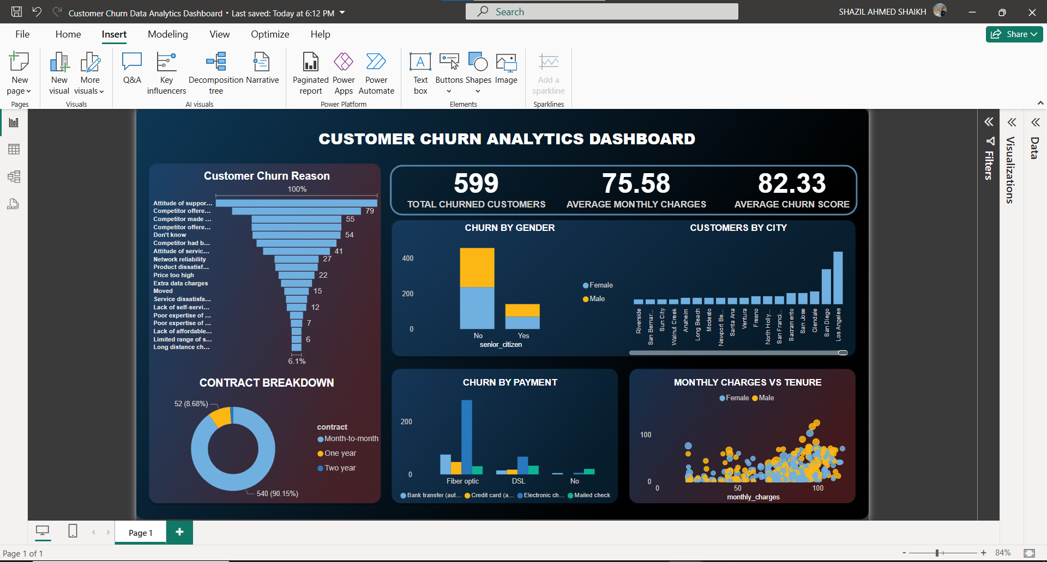
Step 1: Prepare Your AWS Environment
1.1 Create S3 Buckets
- Raw Data Bucket: Store your unprocessed data.
- Processed Data Bucket: Store transformed data (e.g., in Parquet format).
- Athena Query Results Bucket: Athena requires a designated S3 bucket to store query results.
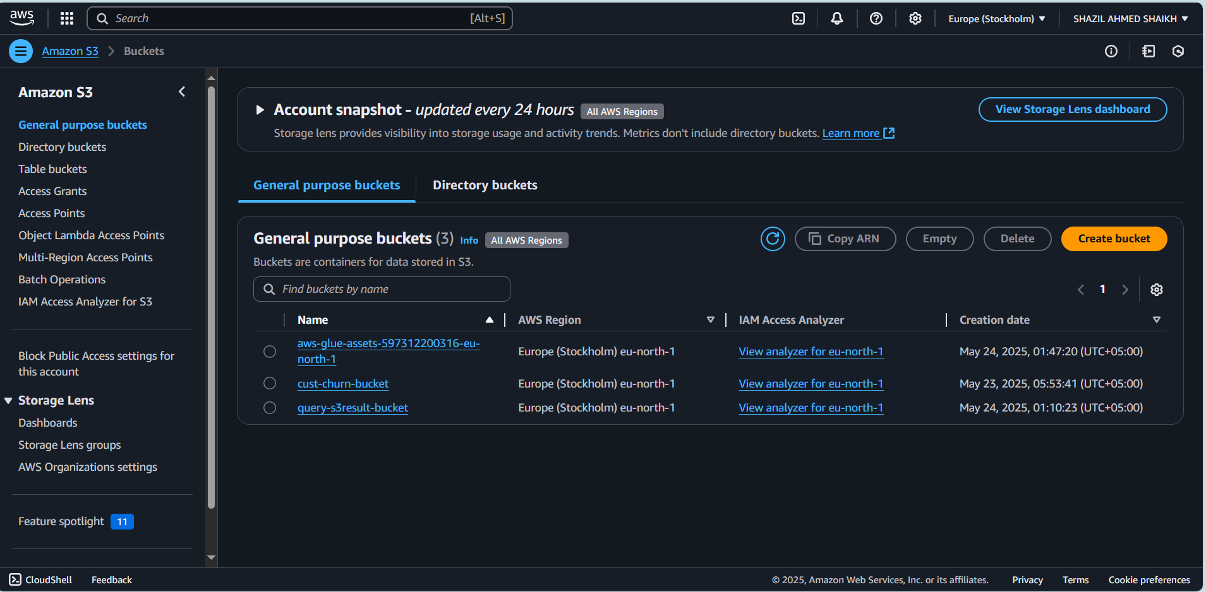

Note: Ensure that the S3 buckets are in the same AWS region as your other services to minimize latency.
1.2 Set Up IAM Roles and Policies
- AWS Glue Role: Create an IAM role with the following permissions:
  - AmazonS3FullAccess
  - AWSGlueServiceRole
  - AmazonAthenaFullAccess
- Power BI Access: Create an IAM user with programmatic access and attach policies:
  - AmazonAthenaFullAccess
  - Permissions to read from the Athena query results S3 bucket.
Step 2: Catalog Your Data with AWS Glue
2.1 Create a Glue Database
- Navigate to the AWS Glue Console.
- Under Databases, click Add database.
- Provide a name (e.g., my_etl_database) and save.
2.2 Set Up a Glue Crawler
- In the Glue Console, go to Crawlers and click Add crawler.
- Data Store: Choose S3 and specify the path to your raw data bucket.
- IAM Role: Select the Glue role created earlier.
- Output: Choose the database you created (my_etl_database).
- Run Frequency: Set to run on demand or schedule as needed.
- After creation, run the crawler to populate the Data Catalog with table definitions.
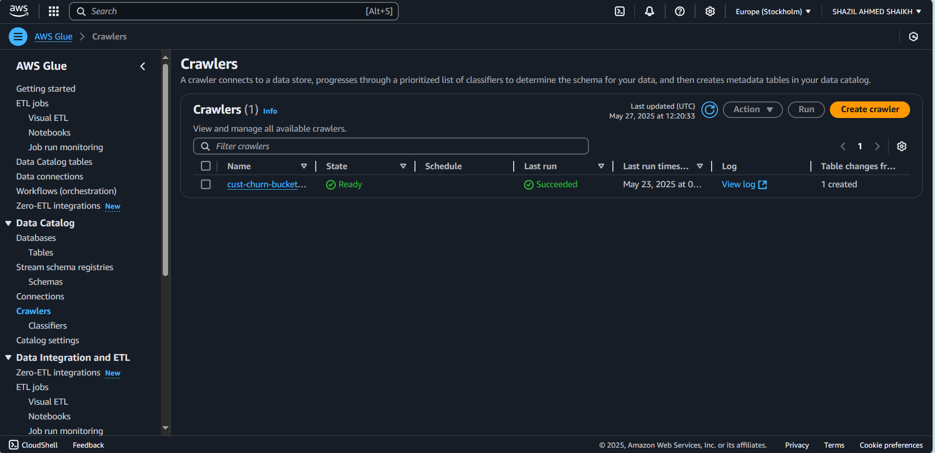
Step 3: Transform Data Using AWS Glue ETL Jobs
3.1 Create a Glue ETL Job
- In the Glue Console, navigate to Jobs and click Add job.
- Name: Provide a meaningful name (e.g., transform_raw_data).
- IAM Role: Use the Glue role created earlier.
- Type: Choose Spark.
- Script: Use either the visual editor or script editor to define your transformations.
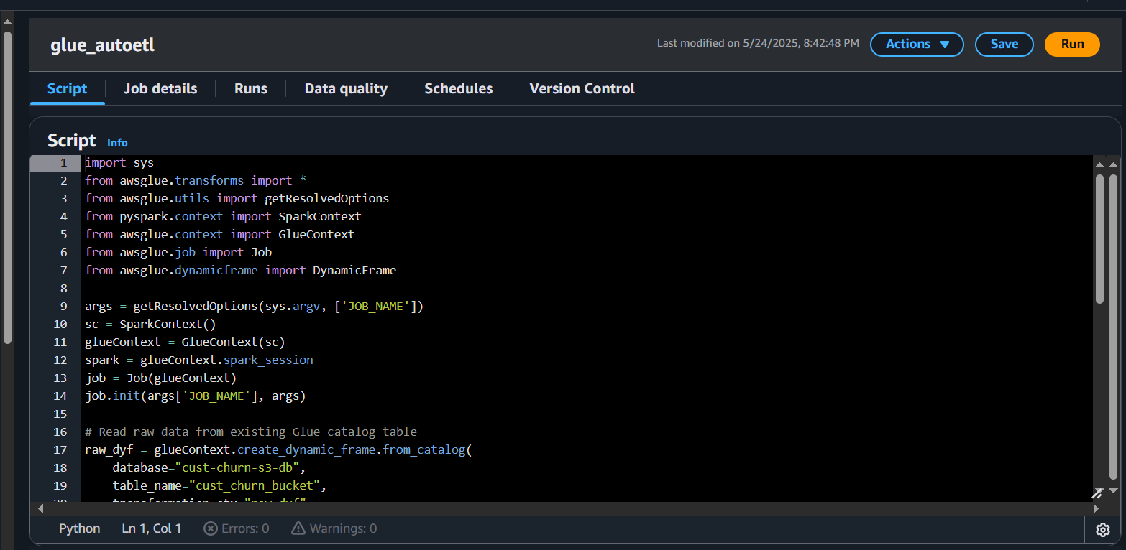
3.2 Define Transformations
- Source: Select the table created by the crawler.
- Transformations: Apply necessary transformations (e.g., data cleaning, format conversion).
- Target: Specify the processed data S3 bucket and choose a format like Parquet for efficient querying.
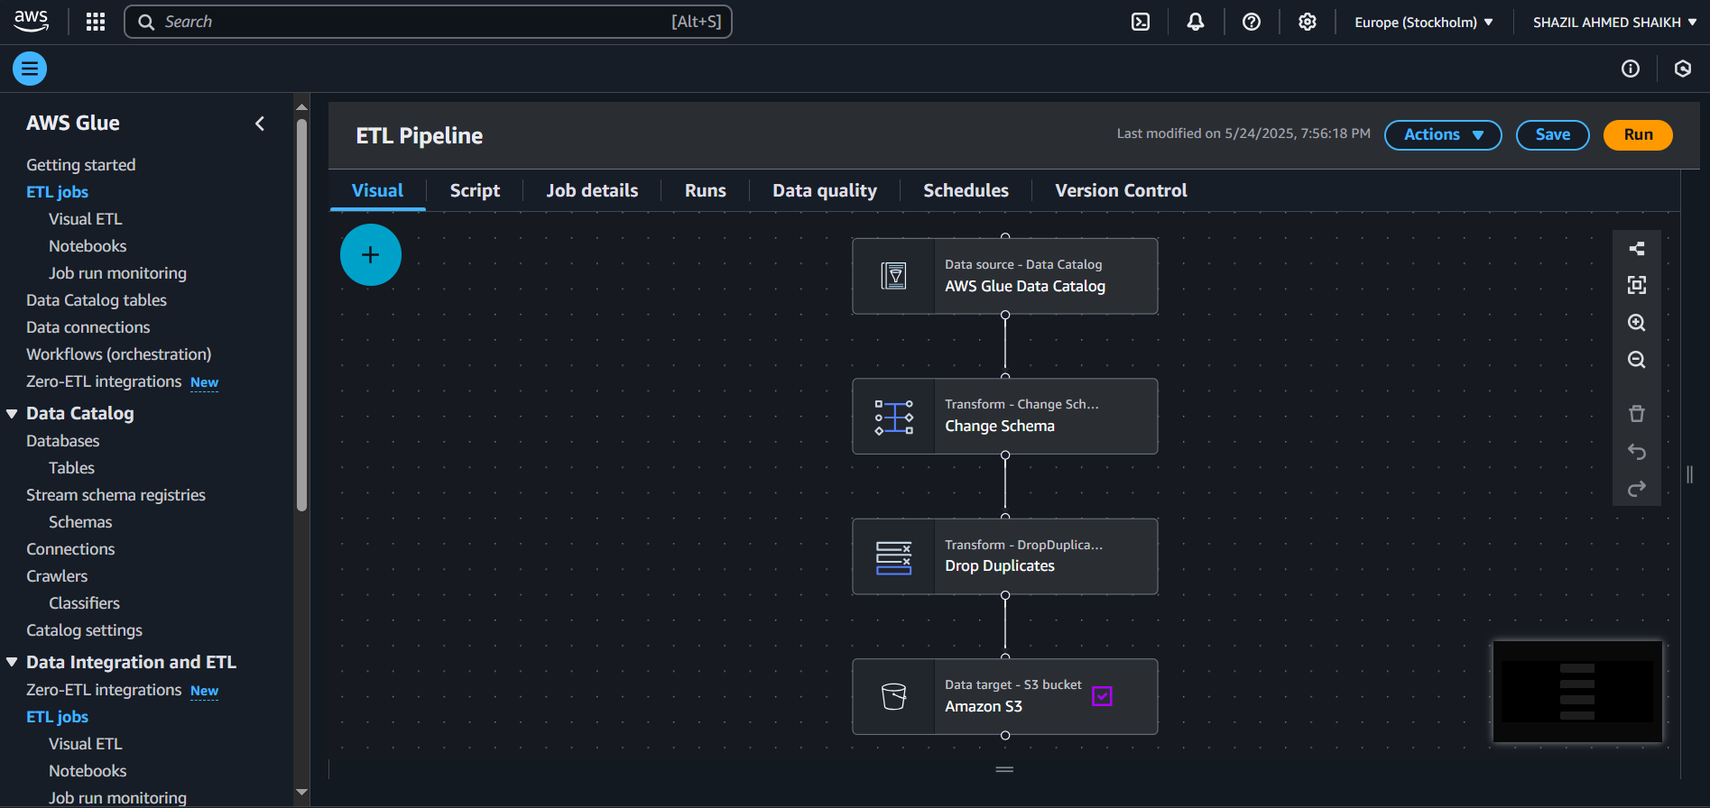
3.3 Run the ETL Job
- Save and run the job.
- Monitor the job's progress and logs to ensure successful execution.
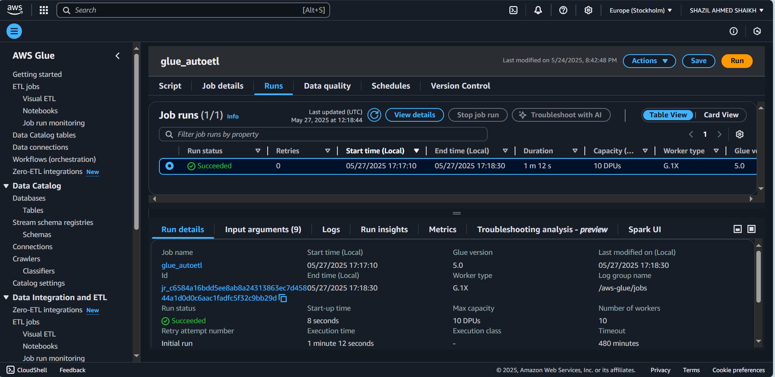
Step 4: Query Processed Data with Amazon Athena
4.1 Configure Athena
- Open the Athena Console.
- Under Settings, specify the S3 bucket for query results.
4.2 Create Tables in Athena
- Use SQL DDL statements to create external tables pointing to your processed data in S3.
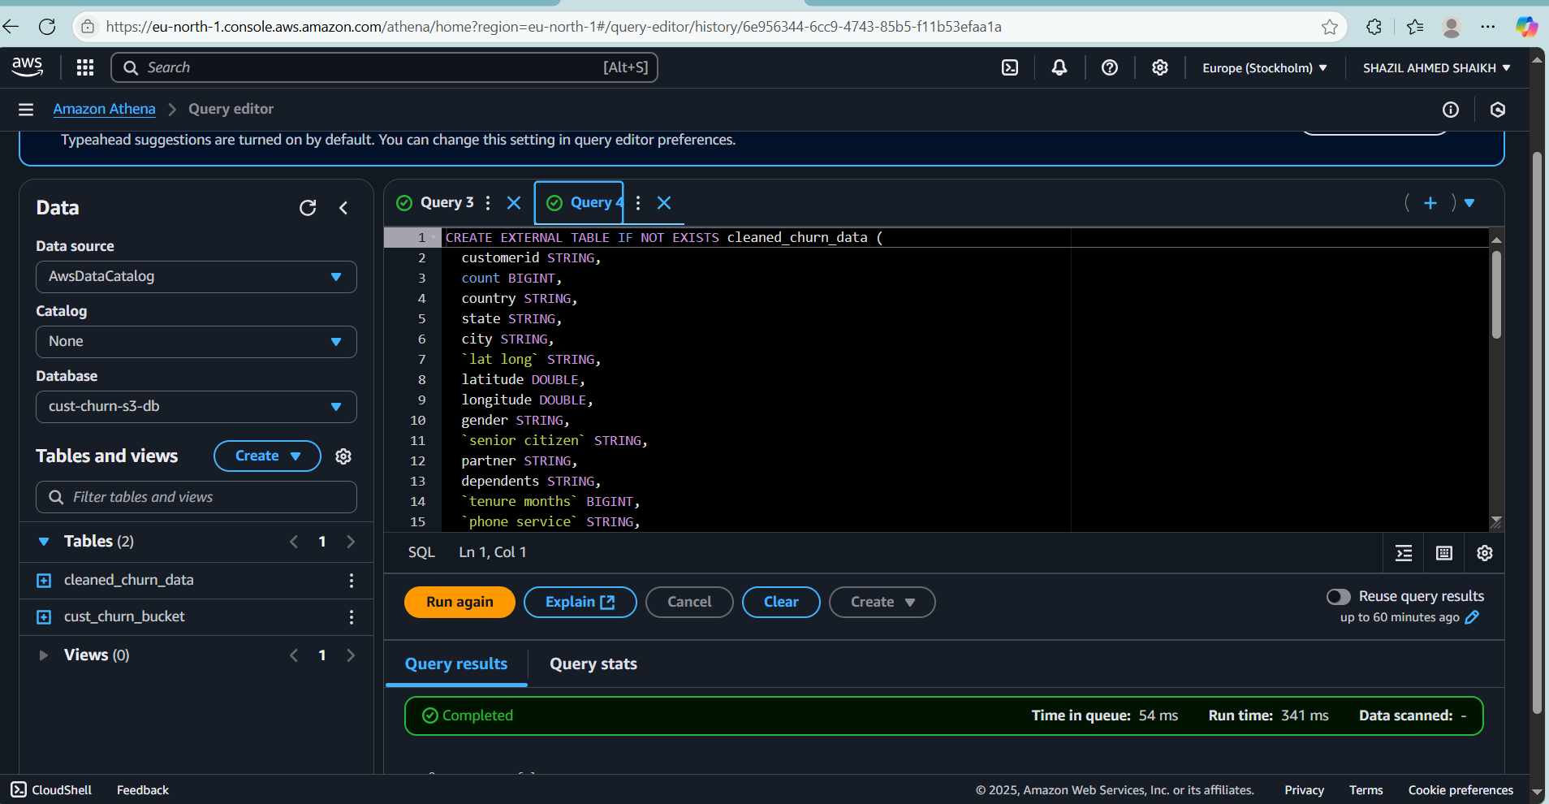
Step 5: Connect Amazon Athena to Power BI
5.1 Install the Amazon Athena ODBC Driver
- Download and install the Athena ODBC driver suitable for your operating system.
5.2 Configure the ODBC Data Source
- Open the ODBC Data Source Administrator on your machine.
- Add a new System DSN:
  - Data Source Name: e.g., Athena_PowerBI.
  - AWS Region: Your Athena region.
  - S3 Output Location: The S3 bucket specified for Athena query results.
  - Authentication: Use the IAM user's Access Key ID and Secret Access Key.
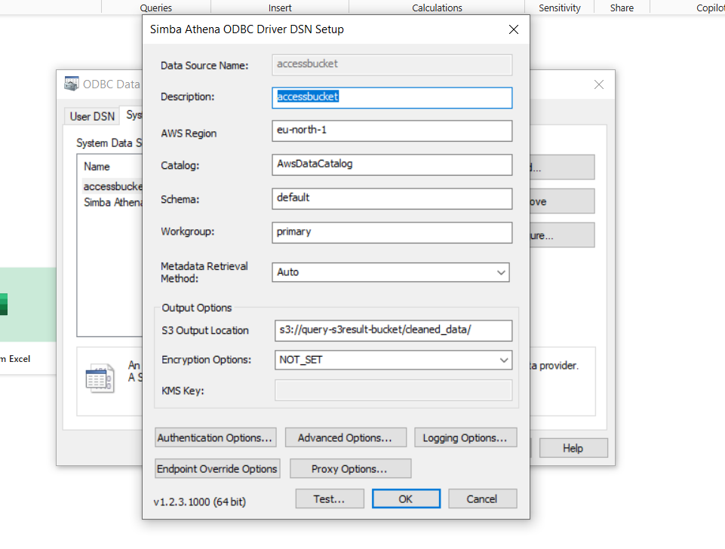
5.3 Connect Power BI to Athena
- Open Power BI Desktop.
- Go to Get Data > ODBC.
- Select the DSN you configured (Athena_PowerBI).
- Choose the appropriate authentication method.
- Select the database and tables you want to visualize.
- Choose between:
  - Import Mode: Loads data into Power BI; suitable for smaller datasets.
  - DirectQuery Mode: Queries data in real-time; suitable for larger datasets.
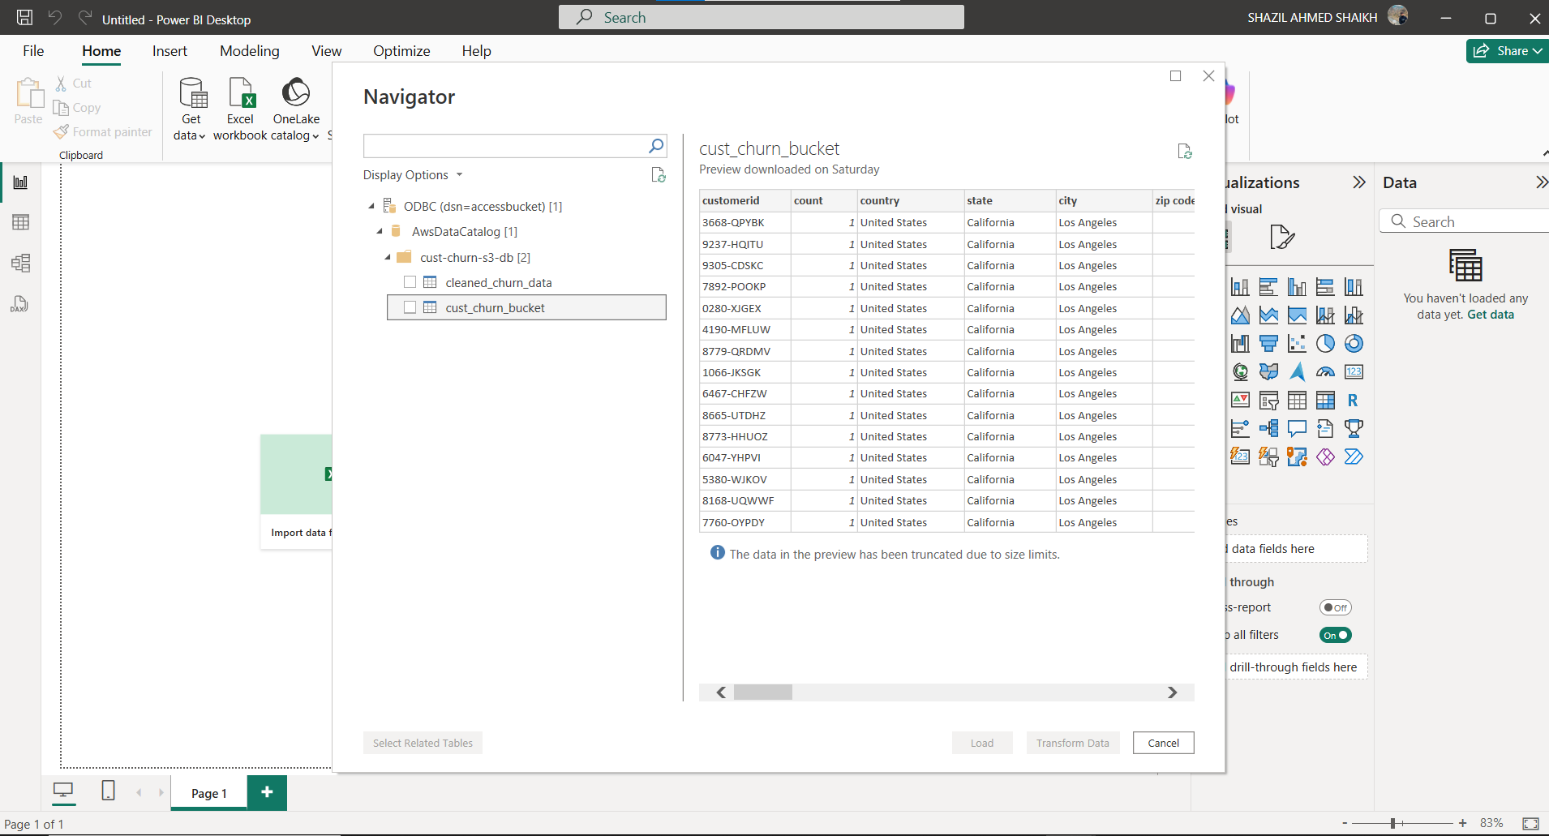

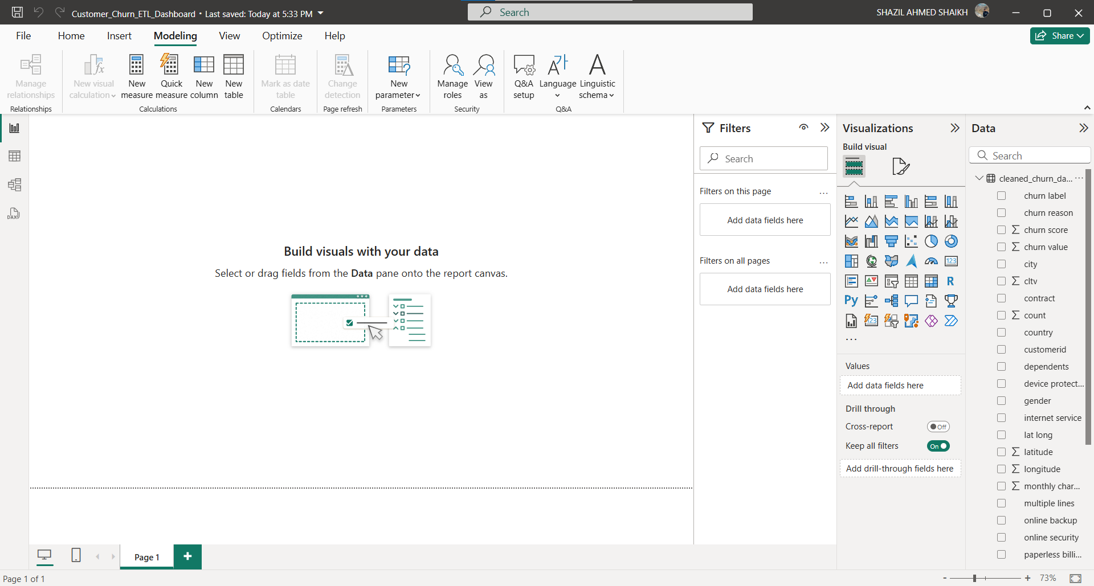


Step 6: Orchestrate the Pipeline Using Apache Airflow
Purpose: Use Airflow to:
- Detect new files in the raw data S3 bucket
- Trigger the Glue ETL job
6.1 Set Up Airflow
You can run Airflow:
- On Amazon MWAA (Managed Workflows for Apache Airflow) — recommended for AWS-native setup
- On an EC2 instance / Docker / ECS / Kubernetes — if self-hosted (Our Case)
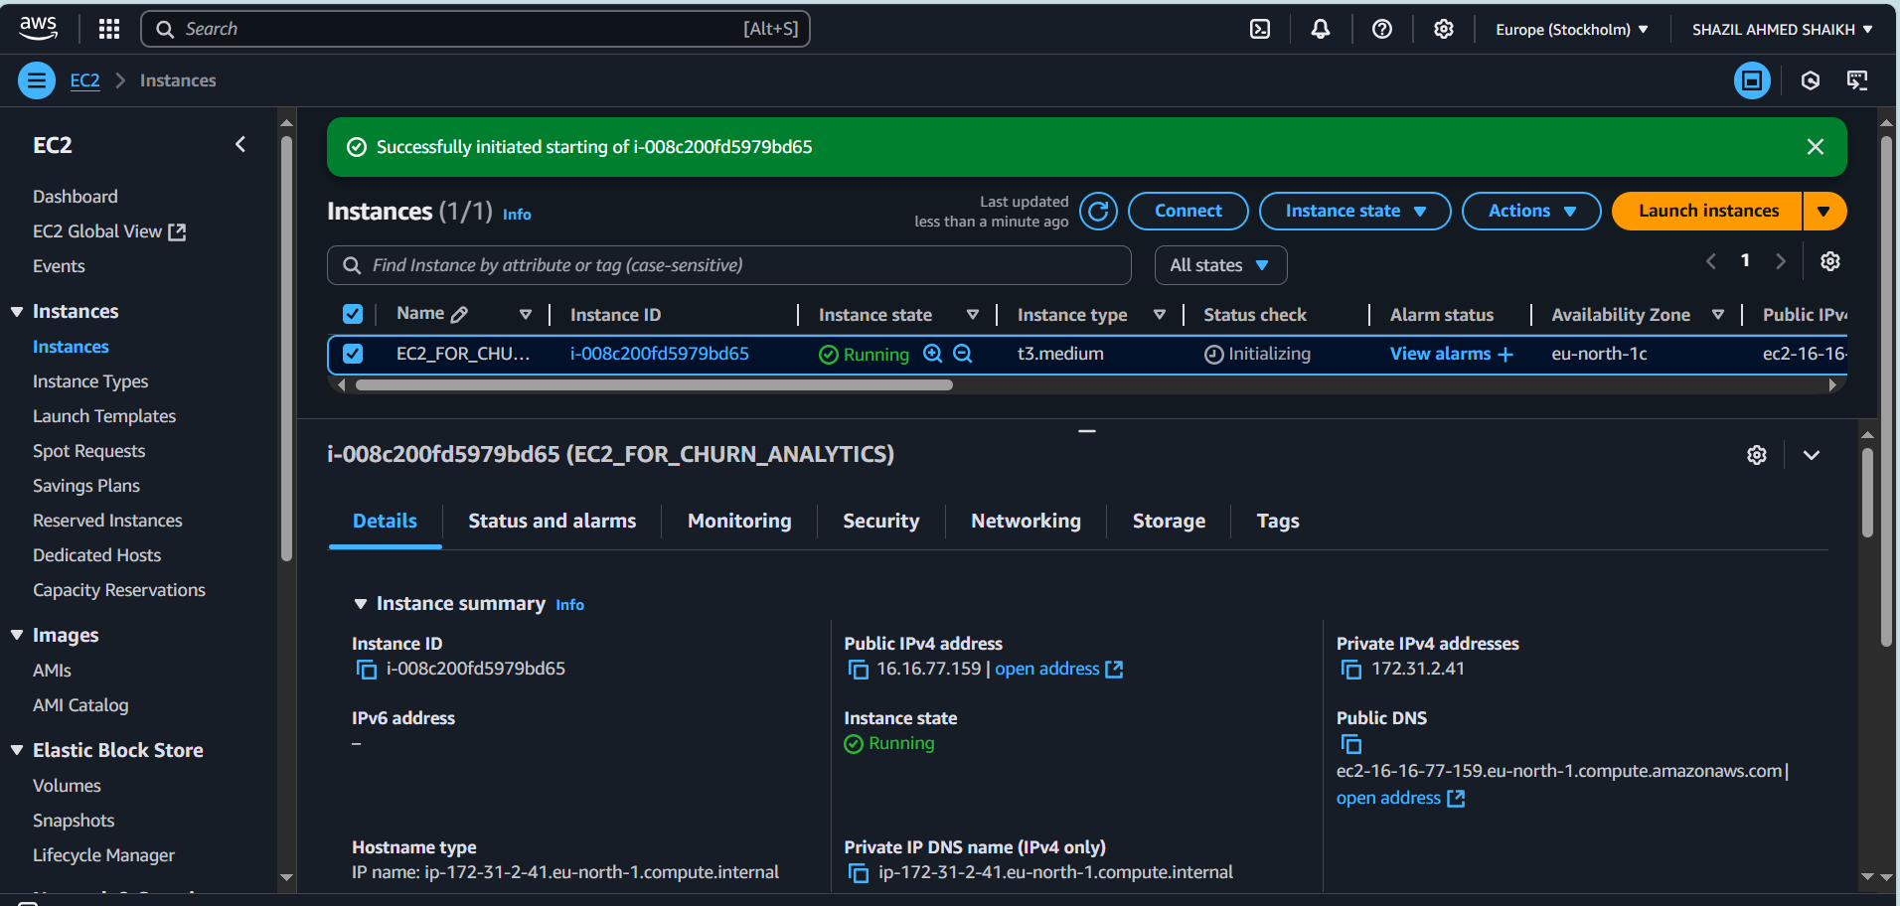
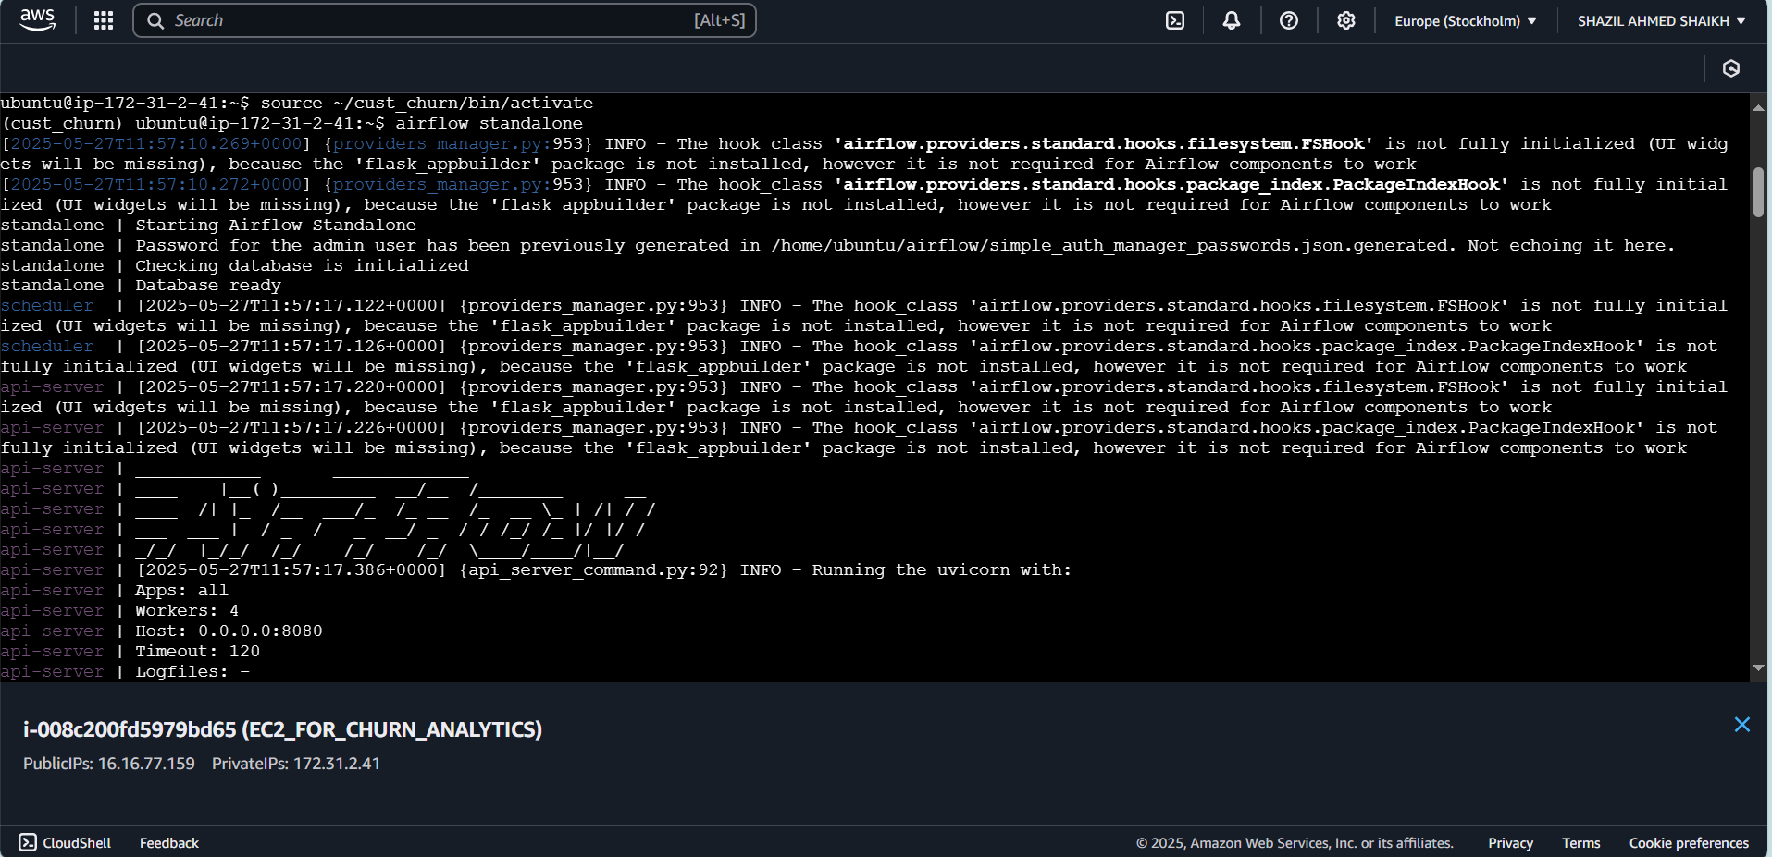
6.2 Define Your Airflow DAG
Create the DAG file: /home/ubuntu/airflow/dags/glue_cust_churn_etl.py
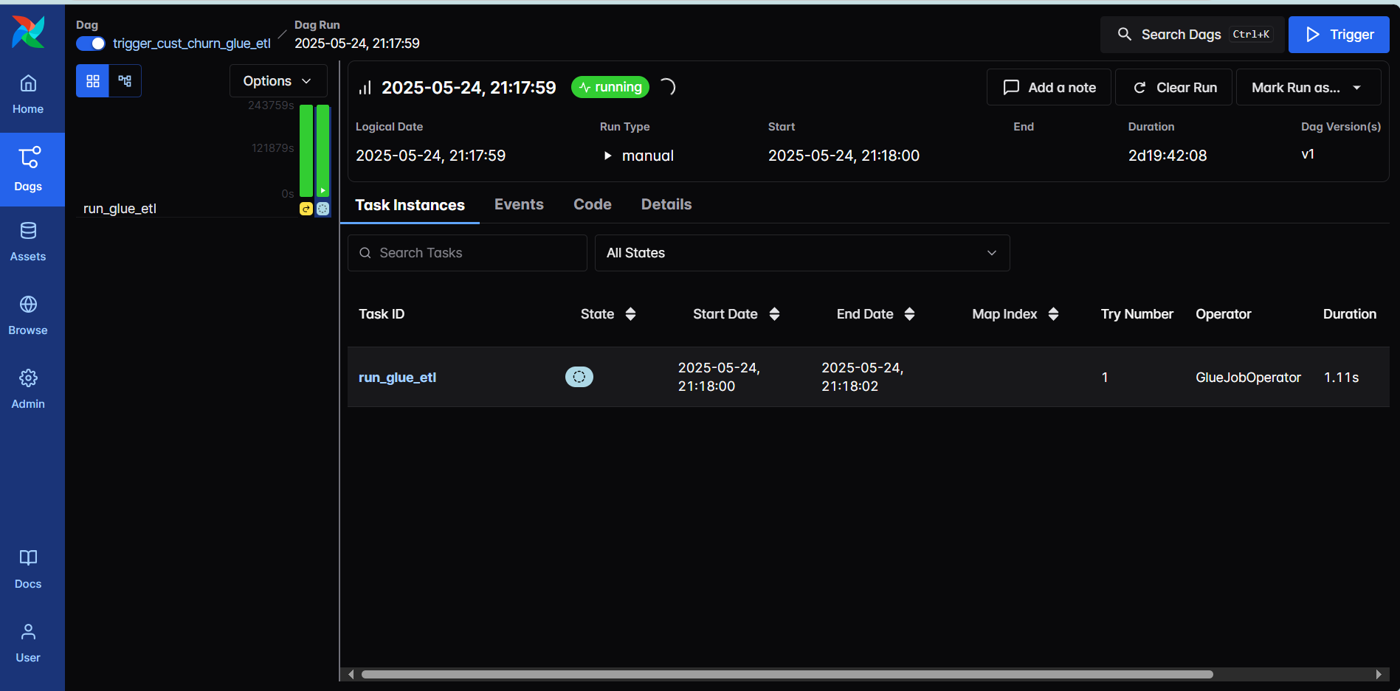

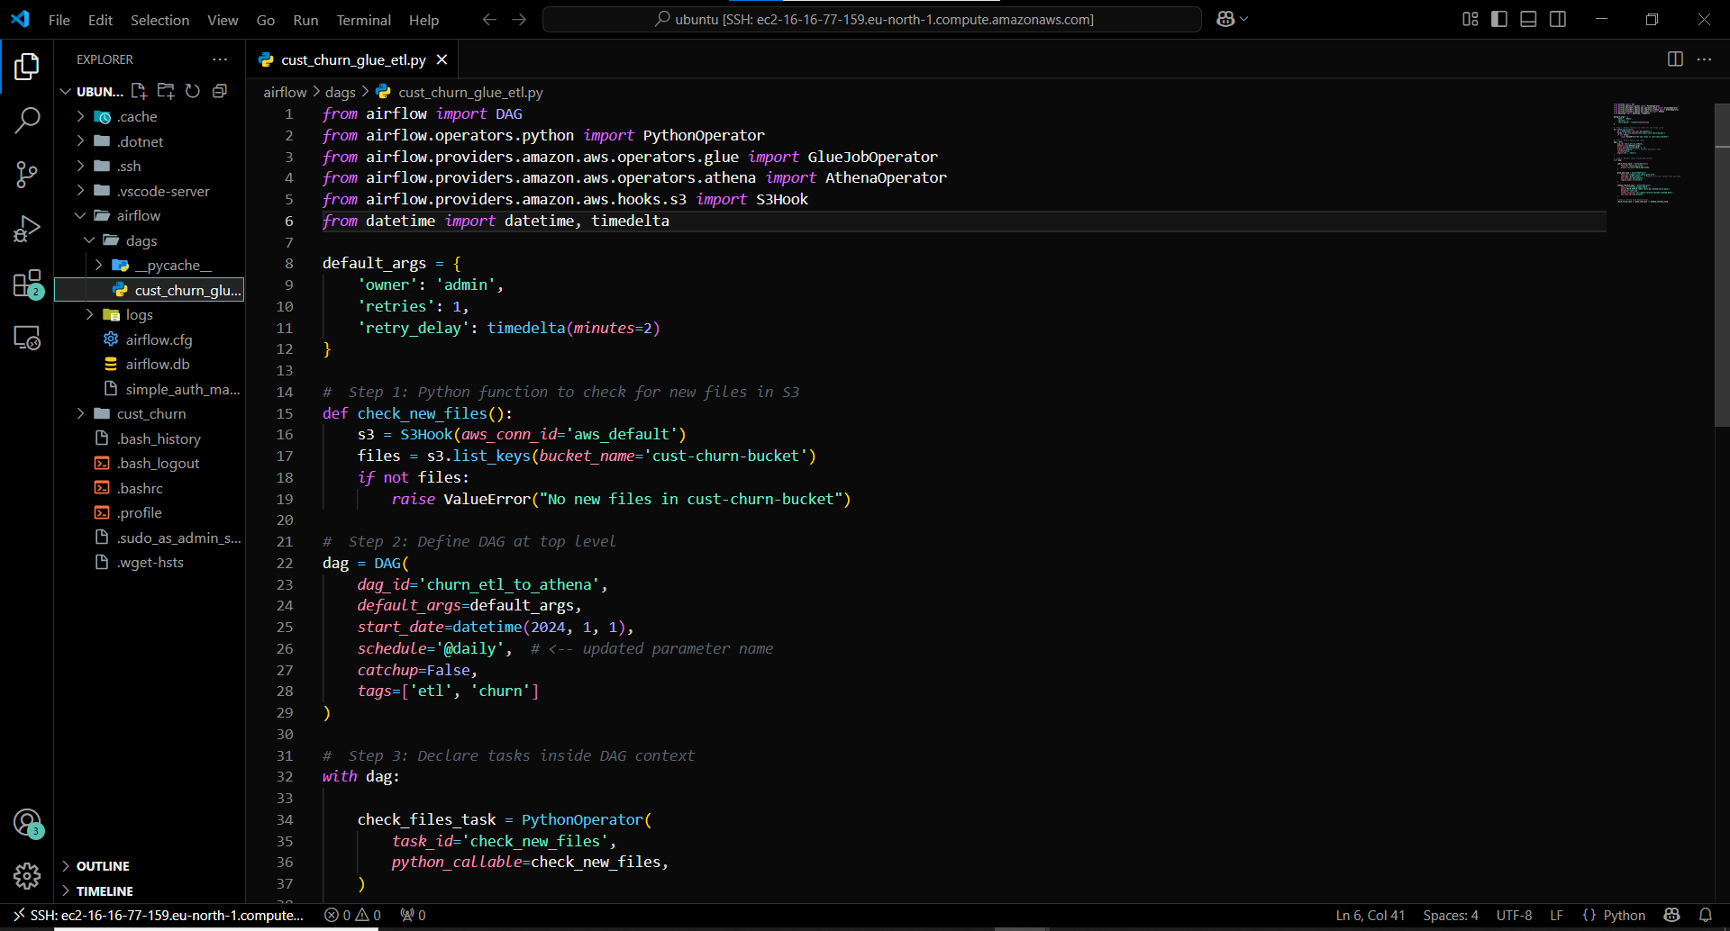

By following these steps, you've established a serverless, cost-effective ETL pipeline:
- Data Ingestion: Raw data stored in S3.
- Data Cataloging: AWS Glue crawlers catalog the data.
- Data Transformation: AWS Glue ETL jobs process and store data in an optimized format.
- Data Querying: Amazon Athena queries the processed data.
- Data Visualization: Power BI connects to Athena for real-time dashboards.
- Automation: Airflow Dag automates the full flow

